**Introduction to Sampling:**

Adapted from G. Thomas (2017), *How to Do Your Research Project: A Guide for Students*, London: Sage., pp. 141-3

**Task 1: Definitions, making connections, & locating relevant sections in the text.**

You are going to work through some activities about *Sampling*.

* Have you heard this term before?
* How does it relate to Research?
* How does it relate to YOUR Research Project?

|  |
| --- |
| If you are unsure of the term – scan the *Glossary* at the back of the book. |

* Scan the text for the word “Sampling”.
* Where are some useful places to look?

**Task 2: Reading for a general impression**

Find a relevant section of the text.

Skim read to find a simple definition of “sampling.”

Make notes in the box below.

|  |
| --- |
| *Sampling*: |

Skim read the text again to answer the following questions. Discuss these questions in groups

* Are there different types of sampling?
* What are the differences between academic and everyday uses of the term?
* How does sampling relate to the idea of “representativeness”
* How does the author feel about the distinction between “theoretical” and “statistical” sampling put forward by “Glaser and Strauss (1967)?

**Task 3: Key words & Definitions**

Scan the text for these key words highlighted in bold in the text.

Skim read the text *around* each of the words.

Match each word to a general definition.

|  |  |  |  |  |  |
| --- | --- | --- | --- | --- | --- |
| **A population** | **Selection bias** | **A random sample** | **A convenience sample** | **A snowball sample** | **A purposive sample** |
| **e.g. 4** |  |  |  |  |  |

|  |
| --- |
| 1. When participants in a survey choose additional participants, pointing the researcher in the direction of other people to involve in the research process. |
| 1. When all members of a population have an equal chance of being selected as participants. An attempt to reduce bias, but difficult to achieve in reality. |
| 1. A method based on the ease of selecting participants. Often the researcher knows the participants or has easy access to this group of people. |
| 1. The group of people that your sampling methods aim to represent. |
| 1. Deliberately targeting specific individuals to participate in the research. Unconcerned about issues of bias. |
| 1. Misrepresentative of data or unrepresentative of the target population due of the researcher’s own priorities. |

**Task 4: Reflection & Application**

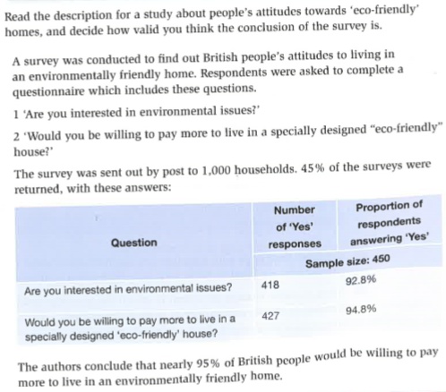

Compare the sampling techniques in these 2 studies.

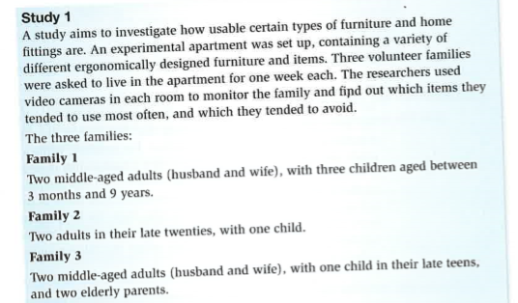

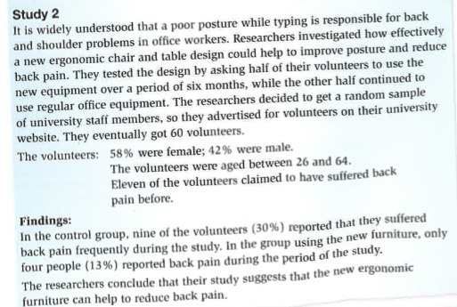

Taken from C. Fletcher, (2011), Skills of Study, Level 2, Cambridge: Cambridge University Press, pp. 215-7