**Creating Simple Graphs in Excel**

Open a new Excel workbook. In the first column, enter the labels describing the data.

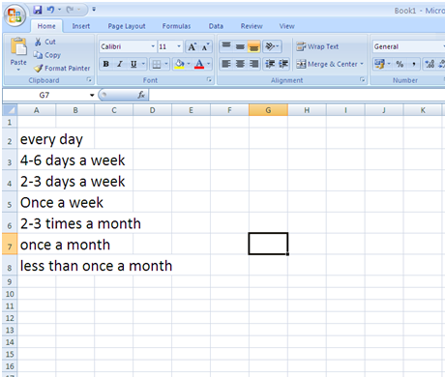

In the next column, put the data you want to display. Don’t leave any blank columns.

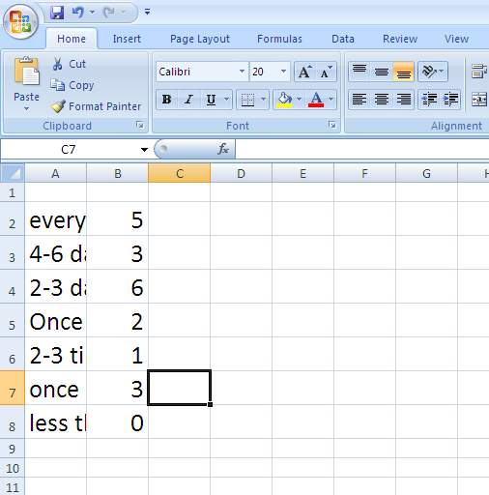

Highlight both columns. Then go to *Insert* and select the type of graph you want. Remember to select an appropriate type of graph for the data you want to display.

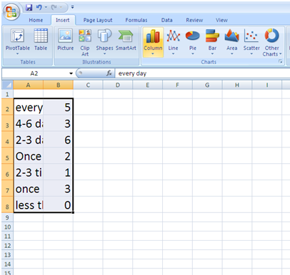

This will create a graph. You can change the colour and design by clicking on the *Design* tab and selecting the style and colour you want.

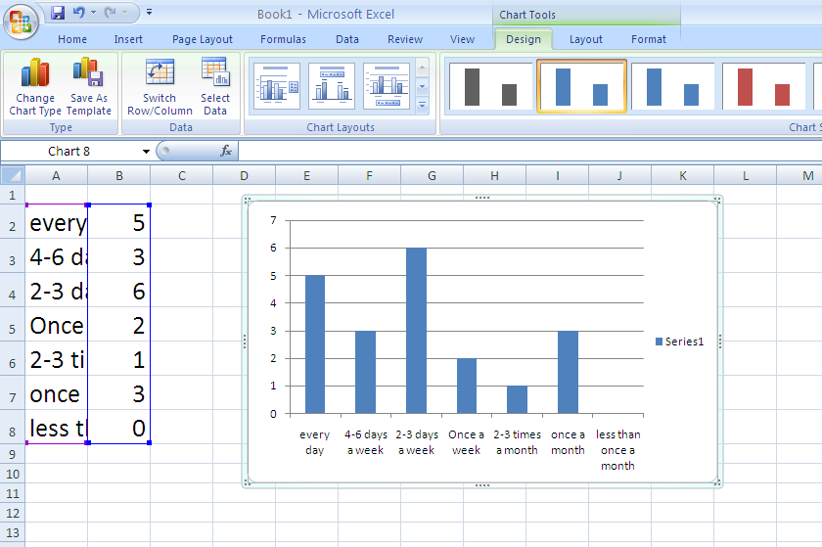

You can then add axes titles and a chart title by clicking on the *Layou*t tab. Your finished graph should look like this:

**Analysing Data**

If you want to use descriptive statistics to analyse your data, first of all you need to install the Data Analysis Toolpak. Follow these steps:

**NB: for first two steps above it may be necessary to click ‘File’ and then ‘Options’**

In the spreadsheet below, data from a question on participants’ ages has been entered (participant numbers are in the left hand column and age in the right hand column).

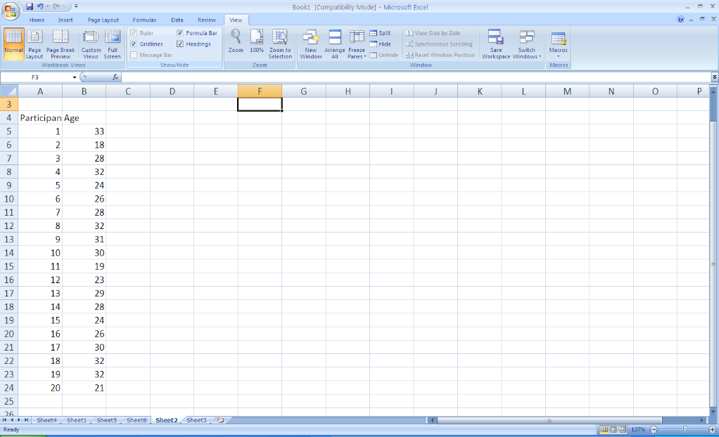

To find out the mean, mode and median, simply click on the *Data* tab and then the Data Analysis button on the right.

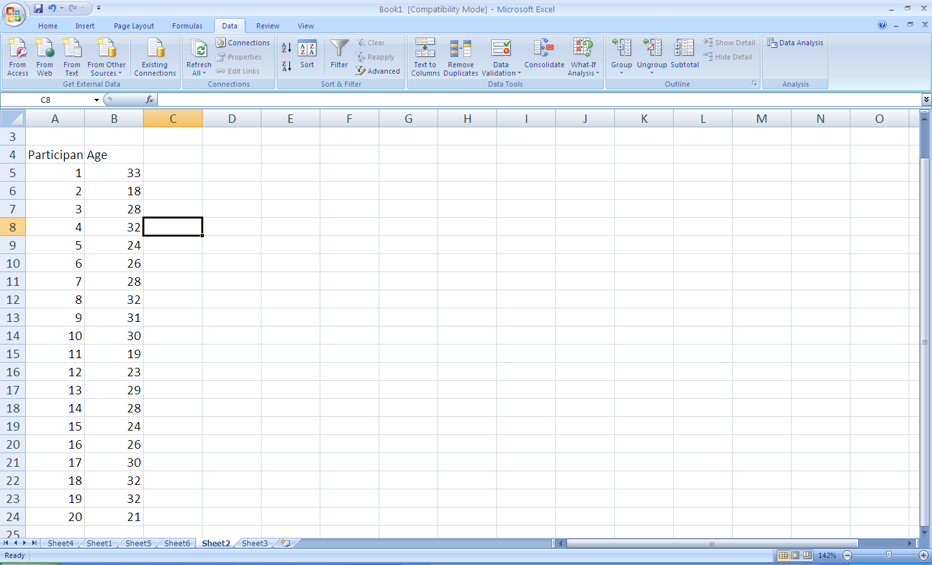

Select Descriptive Statistics from the list of tools.

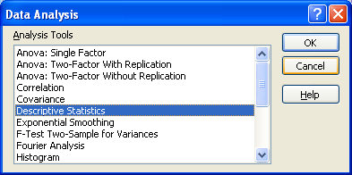

Highlight the right hand column and choose summary statistics.

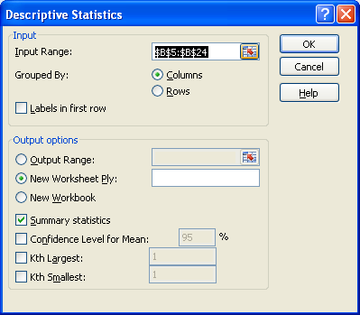

This will give you calculations for the mean, mode and median as well as the standard deviation.

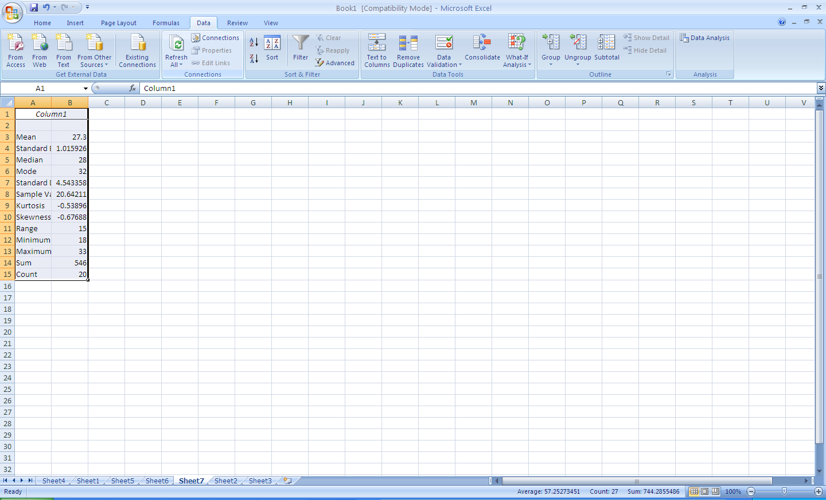

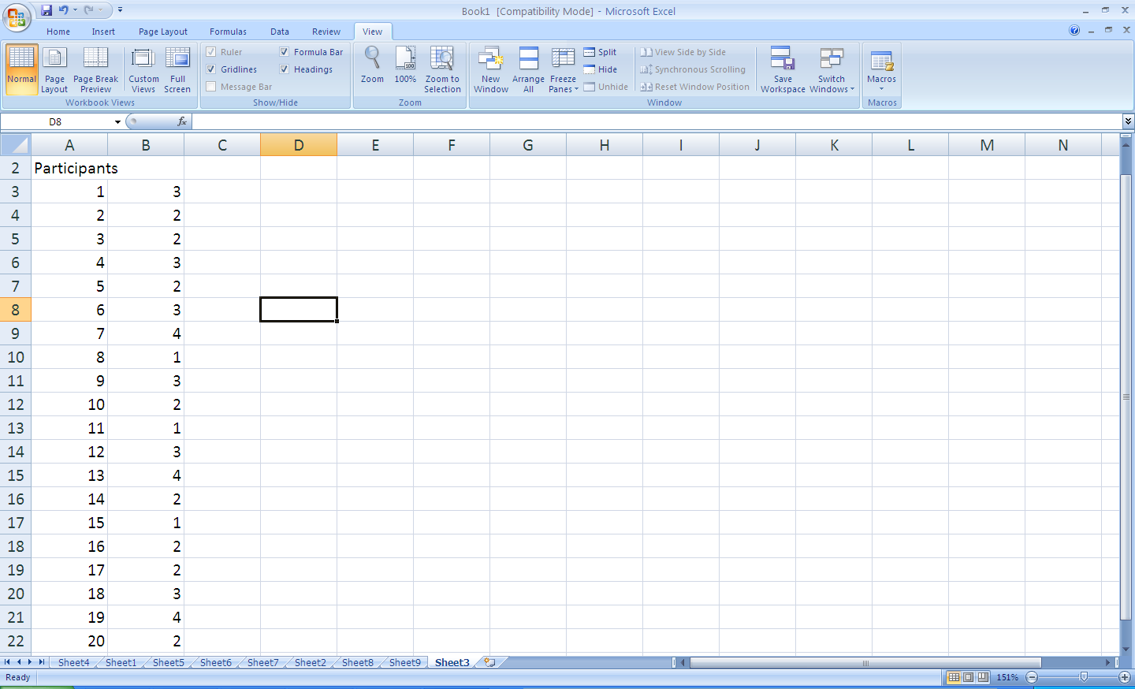We can also use this with data from Likert scales. For example, the screenshot shows data from the following question *I feel happy with the current facilities on offer at the gym. Choose from 1-5 where 1 means strongly agree and 5 mean strongly disagree.* Participant numbers are shown in the left hand column while their choice from the Likert scale is shown in the right hand column.

You can then calculate the mean in the same way as before. We can see here that the mean is 2.4. What does this tell us?

|  |  |
| --- | --- |
| Mean | 2.444444 |
| Standard Error | 0.231819 |
| Median | 2 |
| Mode | 2 |
| Standard Deviation | 0.983524 |
| Sample Variance | 0.96732 |
| Kurtosis | -0.80188 |
| Skewness | 0.173466 |
| Range | 3 |
| Minimum | 1 |
| Maximum | 4 |
| Sum | 44 |
| Count | 18 |

If you would also like to display your data in a graph, highlight the right hand column and click the *Data* tab and then *Filter*. Select *Sort Smallest to Largest.*  The numbers will then be easier to count.

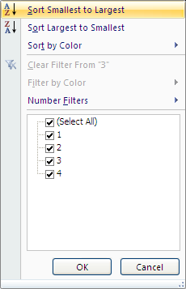

Give the categories names (not numbers as this confuses Excel) in the left hand column and add the numbers in the right hand column.

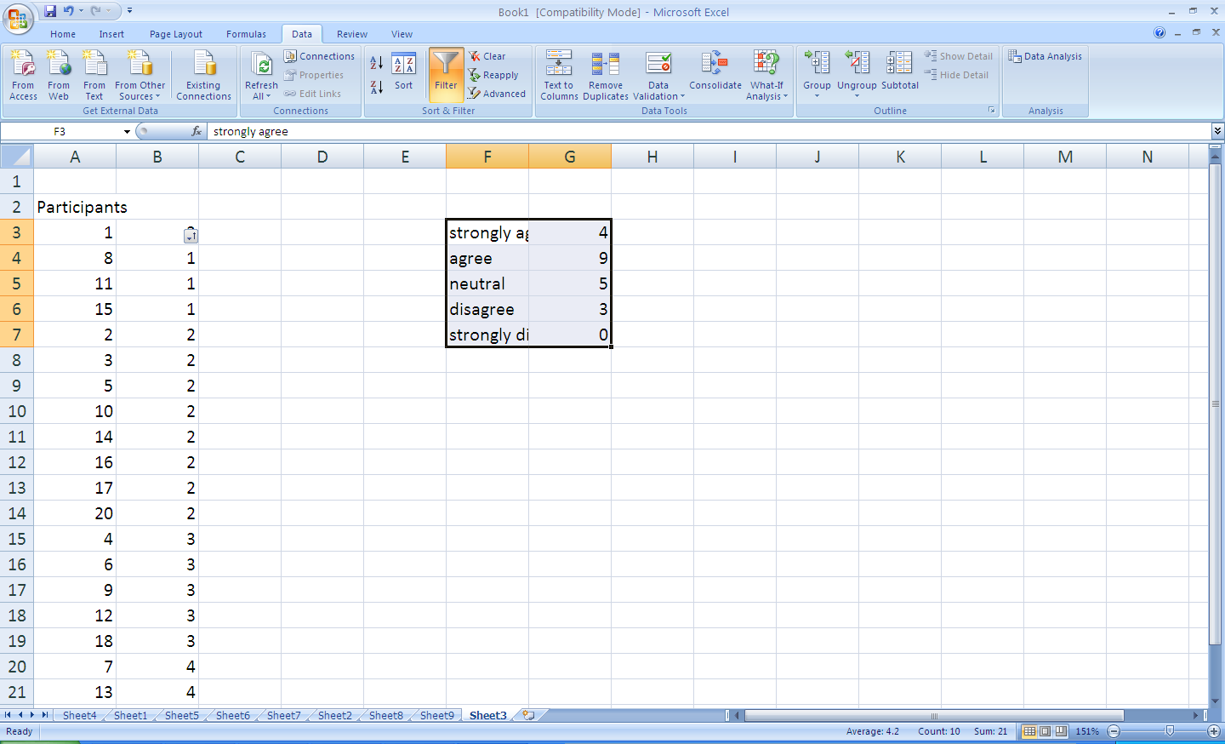

You can then make a graph as before.