Theme 10: Findings
Using Graphics in the Findings Chapter

Include these elements in the Findings chapter:

- Graphic introduction
- Graphic (e.g. chart, graph, table)
- Graphic labels described
- Graphic number
- Graphic title
- Source of data*
- Indication of whether the graphic was adapted from a source/multiple sources*
- Mention of significant results
- Different ways of describing data (e.g. percentages, words like ‘majority’, ‘three-quarters’)

*Secondary research

TASK: Identify elements A-I in the extract below.
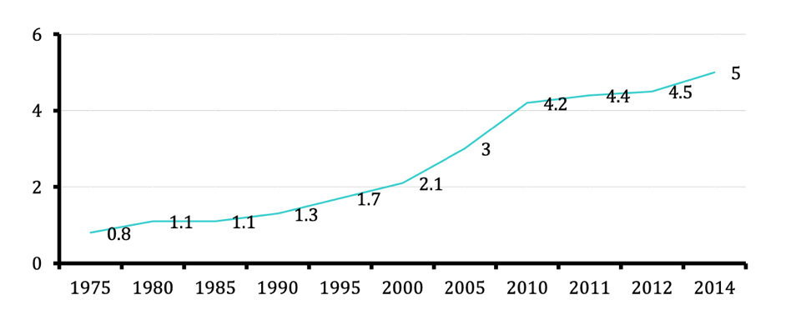
Over the last decade, the rapid growth in international student mobility has made it an increasingly significant feature of the higher education landscape, as shown in Figure 2-1 below.
Figure 2-1 Growth in the number of international students (1975-2014, in millions).
(Adapted from: OECD, 2016: 76)
Universities worldwide, especially those in Europe, Oceania, and North America, have seen rapid development in the internationalization of education. According to the statistics presented in Education at a Glance 2016: OECD Indicators (see Figure 2-1), from 1975 to 2014 the number of international students who enrolled outside their own country rose dramatically, from 0.8 million worldwide to 5 million, more than a five-fold expansion over the three-decade period. It is worthy of note that in the 12 years from 2000 to 2014 the number of international students more than doubled, with an average annual growth of around 7% (OECD, 2016).

Adapted from:
Yu, Y. (2017). Church participation as intercultural encounter in the experiences of Chinese international students in the UK. PhD thesis. University of Glasgow.

