Theme 01: Introducing Research

The research cycle

Research needs to be properly organised and carefully planned. It needs to be systematic. We often call this the research cycle.

In pairs, discuss and decide, which step goes where on the cycle.

*Match the steps a-g to the order 1-7 in the cycle.*

1. Enough information?
2. Scan and review results
3. Assignment topic
4. Critically evaluate results
5. Report/Essay/Presentation etc.
6. Search for information
7. Devise a search plan – search terms and strategies

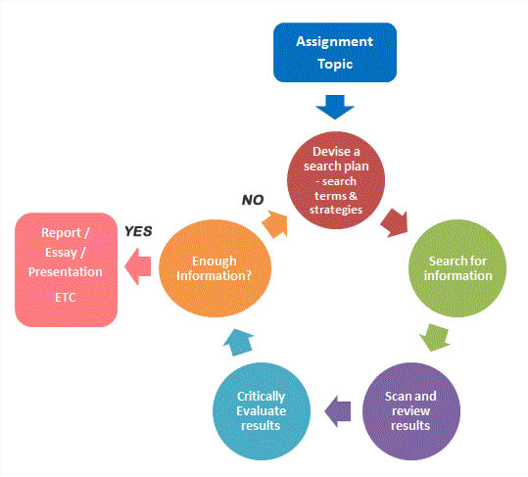

1

2

3

4

5

6

7

|  |  |
| --- | --- |
| Module Learning Outcomes Covered | Academic Literacies Covered |
| ML1 | AL7 |
| Choose an item. | AL13 |
| Choose an item. | AL4 |