

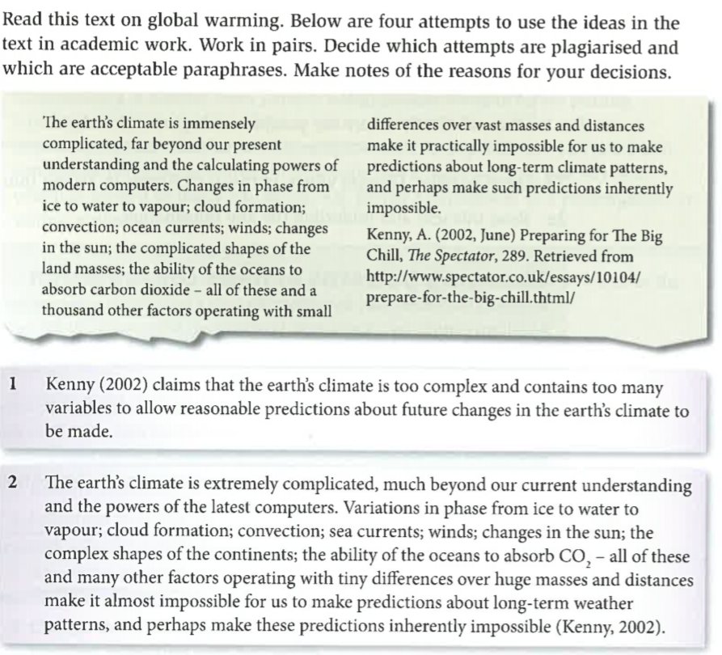

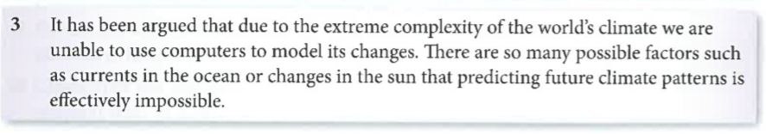

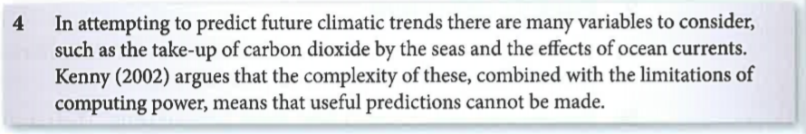

(From: Fletcher, C. & Matthews, B. (2011) *Skills for Study*. Cambridge: CUP)