Theme 13: The Product

Evaluating poster presentations

**Task 1: Evaluating posters**

Look at the two posters. With a partner, consider the questions and note your ideas in the table below.

|  |  |  |
| --- | --- | --- |
| Feature | Poster A | Poster B |
| Logical organisation? |  |  |
| Clear headings/suitable labels? |  |  |
| Suitable amount of text?  Easy to read? |  |  |
| Bullet points/numbering effective? |  |  |
| Clear use of visuals? |  |  |
| Effective use of colour? |  |  |
| Amount of blank space? |  |  |
| Overall effect? |  |  |

**POSTER A**

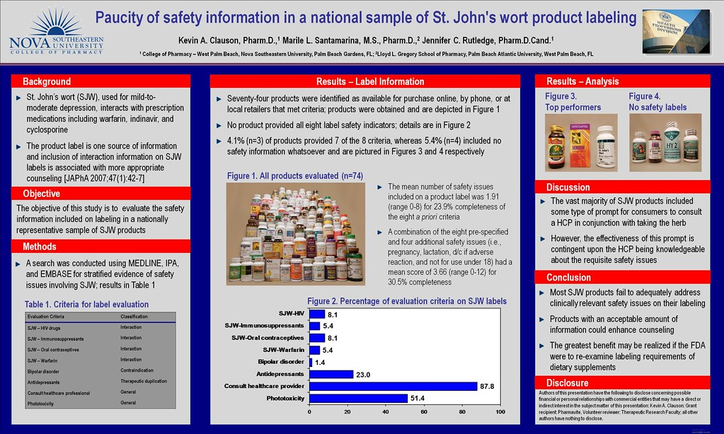

Source: [*"Paucity of safety information in a national sample of St. John's wort product labeling"*](https://www.flickr.com/photos/47229990@N06/5463490189)*by*[*kclauson*](https://www.flickr.com/photos/47229990@N06)*is licensed under*[*CC BY 2.0*](https://creativecommons.org/licenses/by/2.0/?ref=ccsearch&atype=rich)

**POSTER B**

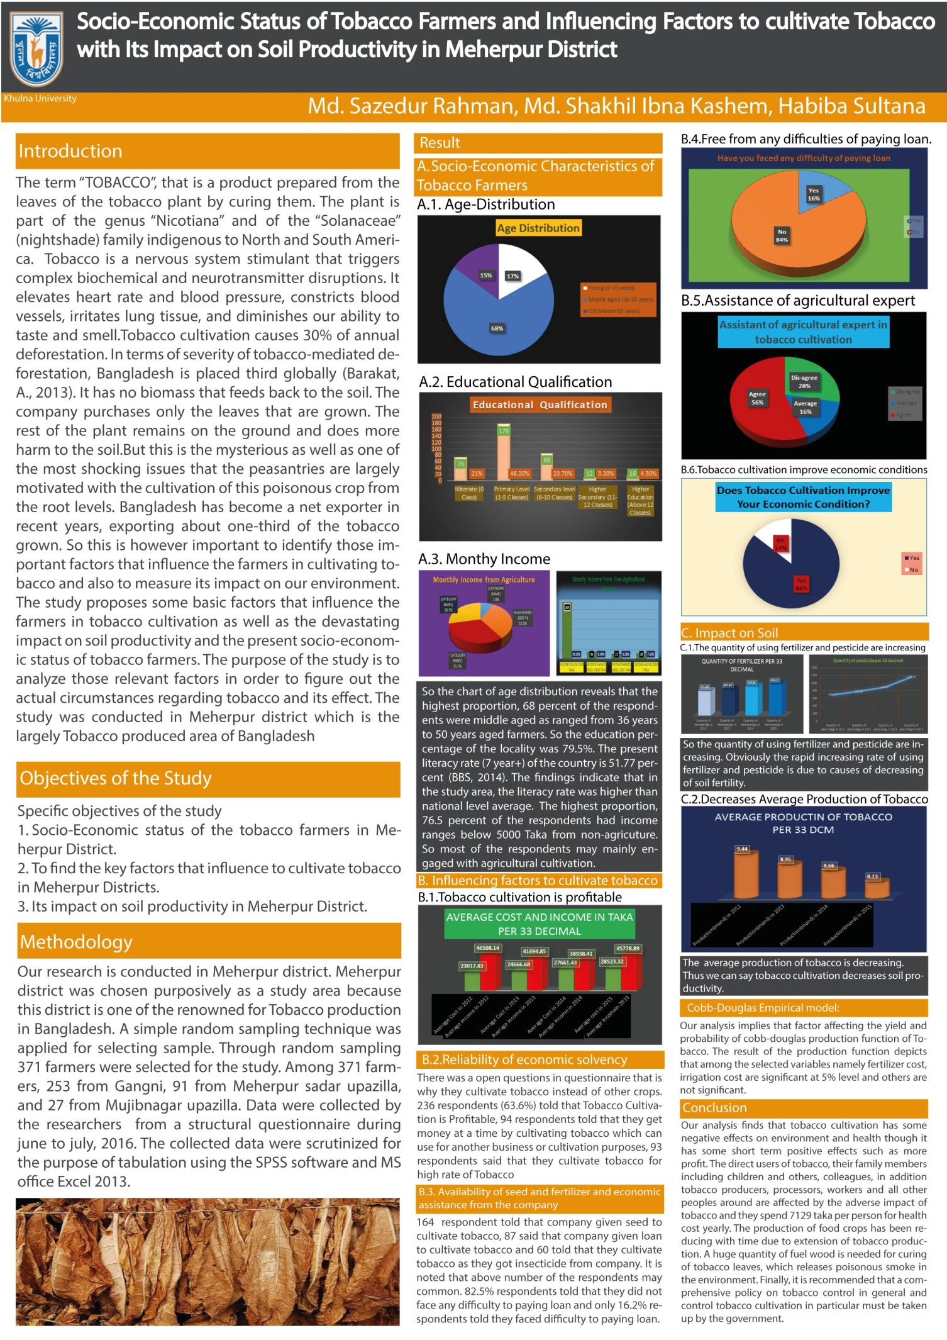

|  |  |
| --- | --- |
| Module Learning Outcomes Covered | Academic Literacies Covered |
| ML5 | AL5 |
| Choose an item. | Choose an item. |
| Choose an item. | Choose an item. |