**Additional Information**

# Balanced Networking Scorecard

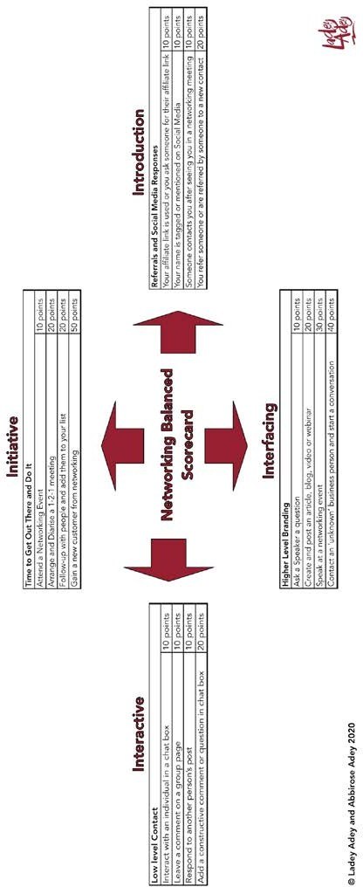

**Your Path, Your Way to Successful Networking**

# Your Networking Scores

P

rint off this page and use this table to add up your score on a weekly basis. Give yourself points for EVERY time you do an activity.

The only competition here is with yourself. It provides vital data to your networking activity; to help decide whether you are receiving a good return on your investment.

|  |  |  |
| --- | --- | --- |
| ***Your Networking Scores*** | | |
| Week Commencing: | | |
| **Activity** | **Points** | **Your Score** |
| **Initiative (Get Out There & Do It)** | | |
| Attending a Networking Event | 10 |  |
| Arrange and Diarise a 1-2-1 Meeting | 20 |  |
| Follow up and Add Contact to List | 20 |  |
| Gain a New Customer from Networking | 50 |  |
| **Total** |  |  |
| **Introduction (Referrals and Social Media)** | | |
| Your affiliate link is used or you ask someone for their affiliate link | 10 |  |
| Your name is tagged or mentioned on Social Media | 10 |  |
| Someone contacts you after seeing you in a networking meeting | 10 |  |
| You refer someone or are referred by someone to a new contact | 20 |  |
| **Total** |  |  |
| **Interfacing (Higher Level Branding)** | | |
| Ask a Speaker a question | 10 |  |
| Create and post an article, blog, video or webinar | 20 |  |
| Speak at a networking event | 30 |  |
| Contact an ‘unknown’ business person and start a conversation | 40 |  |
| **Total** |  |  |
| **Interaction (Low Level Contact)** | | |
| Interact with an individual in a chat box | 10 |  |
| Leave a comment on a group page | 10 |  |
| Respond to another person’s post | 10 |  |
| Add a constructive comment or question in chat | 20 |  |
| **Total** |  |  |

**Additional Information**

For each month do a summary sheet using your weekly score results.

|  |  |
| --- | --- |
| ***Your Networking SUMMARY Scores*** | |
| Month: | |
| **Activity** | **FINAL**  **Scores** |
| **Initiative (Get Out There & Do It)** | |
| Attending a Networking Event |  |
| Arrange and Diarise a 1-2-1 Meeting |  |
| Follow up and Add Contact to List |  |
| Gain a New Customer from Networking |  |
| **Total** |  |
| **Introduction (Referrals and Social Media)** | |
| Your affiliate link is used or you ask someone for their affiliate link |  |
| Your name is tagged or mentioned on Social Media |  |
| Someone contacts you after seeing you in a networking meeting |  |
| You refer someone or are referred by someone to a new contact |  |
| **Total** |  |
| **Interfacing (Higher Level Branding)** | |
| Ask a Speaker a question |  |
| Create and post an article, blog, video or webinar |  |
| Speak at a networking event |  |
| Contact an ‘unknown’ business person and start a conversation |  |
| **Total** |  |
| **Interaction (Low Level Contact)** | |
| Interact with an individual in a chat box |  |
| Leave a comment on a group page |  |
| Respond to another person’s post |  |
| Add a constructive comment or question in chat |  |
| **Total** |  |

*A copy of an interactive tool to help you produce your own scorecard is available in the ‘networking skills’ section of Pathways Extra in the Kaplan International Pathways Virtual Learning Environment*.