Theme 10: Findings
Incorporating Data into the Findings Chapter
Below is the Results section of a secondary research journal article entitled ‘Economic conditions of young adults before and after the great recession’. The graphics have been taken out and moved to the Appendix.

Task 1
Add appropriate headings to the Results sections (A-D) below:

- Economic Conditions and Prolonged Education
- Employment Trends and Economic Conditions by Gender
- Descriptive Findings
- What is Associated with Being Low-Paid?

Task 2
Choose titles for the graphics in the Appendix:

- Predicted probability of being low-paid—men
- Being low-paid and enrollment in school—women. a Not controlling for enrollment in school. b Controlling for enrollment in school
- Median income and Low-paid income
- % of Men and women who are considered as low-paid
- Predicted probability of being low-paid—women
- Descriptive statistics—weighted by country and year
- Being low-paid and enrollment in school—men. a Not controlling for enrollment in school. b Controlling for enrollment in school
- % of Men and women working full-time

Task 3
Insert the graphics from the Appendix into the Results chapter. Choose appropriate places for them and remember to label them appropriately by including Table/Figure numbers and titles.

Task 4
In the Results chapter, identify the phrases used to:

- Refer to particular graphics.
- Refer back to research questions, aims or hypotheses.
- Highlight significant/key findings, e.g. trends or majorities.
- Highlight interesting/unexpected findings.
- Compare/contrast data, e.g. data from different countries.

Task 5 (Secondary Research)
In your Findings chapter, you should bring together data from different sources. Did the authors of the article do that? Check here: https://doi.org/10.1007/s10834-017-9554-3

Results

Section A:

Table 2 presents characteristics of the selected samples, by country and survey year. The mean age in the sample was approximately twenty-six in all countries, and the proportion of women ranged between 48.1% (Norway in 2004) and 56.2% (Germany in 2007). As expected, the proportion of people reporting a high level of education increased over time, except in Norway, where the proportion with a tertiary education was already high in 2000 (31.3%). The greatest increase was observed in the UK, where 23.7% of the 2000 sample completed tertiary education, rising to 34.5% in 2007 and 32.8% in 2010. The smallest proportion of people with high education in 2010 was reported in Germany (19.2%). Differences across countries could be due to the fact that the expansion of education unfolded in different ways across countries, both its starting point and the rapidity of expansion. Therefore, educational systems were not homogeneous. These differences should be considered when interpreting the results.

As shown in Table 2, the percentage working full-time decreased over time in each country. The magnitude of the change was, however, quite diverse across countries. In the US, UK, and Norway, there was a small decrease from 2000 to 2007, with a larger drop between 2007 and 2010, which was most likely due to the hit of the crisis.

In Germany, there was a very small decline (3%) between 2000 and 2007, but there was almost no change between 2007 and 2010. In Spain, the trend in the percentage of young adults employed full-time was positive from 2000 to 2007, but this figure dropped drastically in 2010 (from 61.1 to 44.6%).

Macro-level employment rates showed almost no change in Germany and Norway between 2000 and 2010, with some fluctuations within the two periods. Both the US and the UK reported an increase in the unemployment rate, from 4 to 9.6% and from 5.9 to 7.8%, respectively. Coherent with the micro-level statistics, Spain was the country that showed the largest deterioration: The unemployment rate went from 11.9% in 2000 to 19.9% in 2010, which was even worse if we consider that the rate was 8.2 in 2007. It is worth noticing that the unemployment rate referred to the entire population in working age, and not only to the age range (22–30) considered in the analysis.

Section B:

Figures 1 and 2 show the proportion of men and women working full-time and who were defined as low-paid, respectively. Generally, the proportion of young men working full-time decreased over time in all countries. The drop between 2007 and 2010—presumably due to the financial crisis—was quite substantial in the US (− 10.5%) and UK (− 10.2%), and even more in Spain (− 20%). The decrease was less evident in Norway (for which we report the proportion employed) and Germany. The trend was on a negative slope since the beginning of the twenty-first century, but the impact of the recession was very visible. Among young women, the situation was less clear-cut. Everywhere but in Spain the proportion of women working full-time was quite stable, and in the US, UK, and Norway, there was a 5–6% drop after the hit of the recession. In Germany, there was a 2% increase between 2007 and 2010. Spain showed a positive trend from 2000 to 2007—with an increase of almost 10%—but the crisis brought the proportion of women working full-time to a lower level than 2000 (40.3%).

If we look at the proportion of youth defined as low-paid, we observe a very similar trend among men and a quite clear impact of the crisis, especially in Spain, US and UK, where the proportion low-paid increased significantly between 2007 and 2010.

Among women, the trend over time was increasing in all the countries considered here, except for Germany, where there was a decrease from 59.6 to 53.4% between 2000 and 2010.

Section C:

In this section, the main factors associated with economic conditions of young adults were investigated. Through a set of logistic regressions, the predicted probability of being low-paid was computed depending on the year, country of residence, gender and level of education. The margins reported in Figs. 3 and 4 are based on a regression model that includes the following variables: age, gender, country, year, education, and interaction terms between year and gender, year and country variables, and year and education level.

Among men, the probability of being low-paid was always lowest among those with tertiary education, as expected. The levels were also quite comparable across countries. However, the trends over time differed across countries, and also showed a different impact of the economic recession. There was an increase in the predicted probability of being low-paid among young men starting in 2004 in US, UK, Germany, and Spain. In Norway this increasing trend started in 2000. There was an increase in the probability of being low-paid also for those with low and medium education (except than in Germany), especially after the crisis, but it is less pronounced than for those with high education. Very interestingly, across all countries, those who showed a larger increase in the probability of being low-paid between 2000 and 2010 were those with high education. This can be due to education expansion over this period of time. Moreover, the probability of being low-paid kept increasing between 2007 and 2010, which can be explained by the high populations of young men with tertiary education in the economic sectors most influenced by this crisis. However, it can also be due to the fact that these young men decided to stay longer in education (possibly going into graduate school), given the unfavorable conditions of the job market.

Figure 4 presents the results for young women: Probability of being low-paid is higher than for men in each education group, but the trends over time and the impact of the crisis are very similar across genders.

Section D:

As observed in Figs. 3 and 4, the group of young adults that showed the largest increase in the probability of being low-paid between 2000 and 2010 was that of highly educated men and women. Two explanations may be behind this result: On the one hand, it can be that high educated young employees were apart of the economic sectors with a declining performance over time and also got hit hardest by the crisis; on the other hand, it is also possible that young adults—given the lack of jobs—decided to stay in school longer and postpone their entry into the labor market. If including enrollment in school in the logistic regression makes the increase in the probability of being low-paid less marked (especially for those with a high level of education), it means that part of the increase in the probability of being low-paid over time is driven by young men and women staying in school longer, postponing the onset of financial stability.

The top part of Figs. 5 and 6 (part A) reports the analysis shown in Figs. 3 and 4 (without Norway, as there was no information on enrollment in school for 2000, 2004, and 2010), while the bottom part of Figs. 5 and 6 (part B) replicates the analysis including enrollment in school. It is very visible how in every country the increasing trend in the probability of being low-paid for high-educated young adults became much less pronounced. The changes were less marked for those with medium or low levels of education. This confirmed the hypothesis that the greater deterioration in financial conditions for those with high education between 2000 and 2010 was largely explained by their prolonged enrollment in school.

Appendix

A

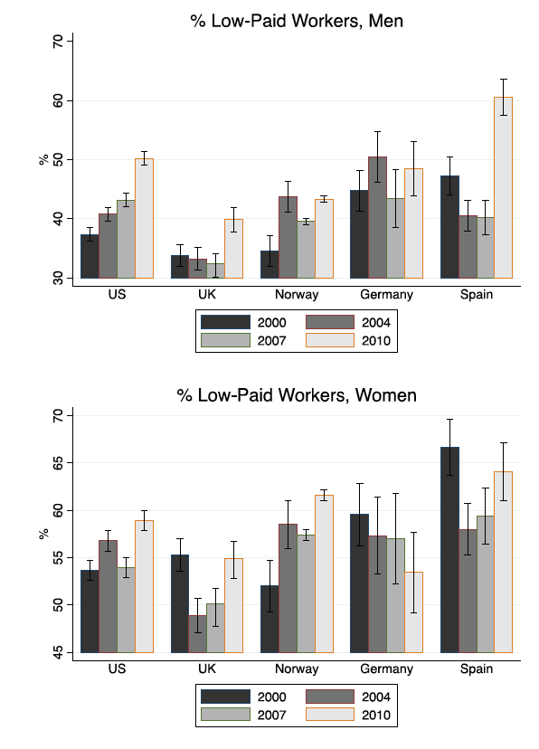

B

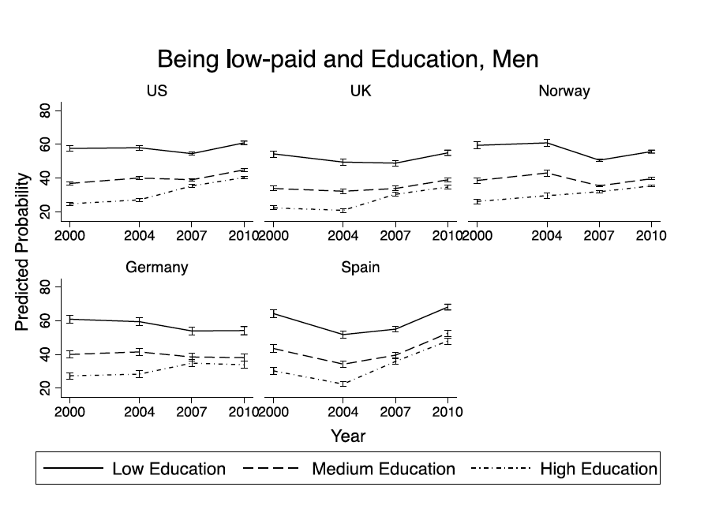

C

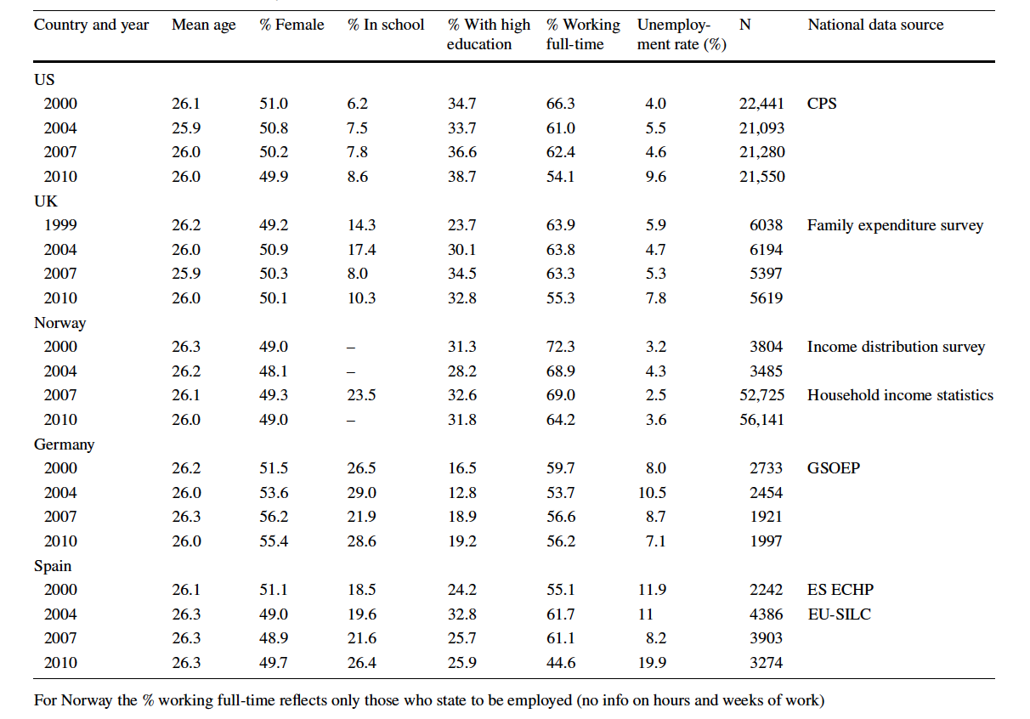

D

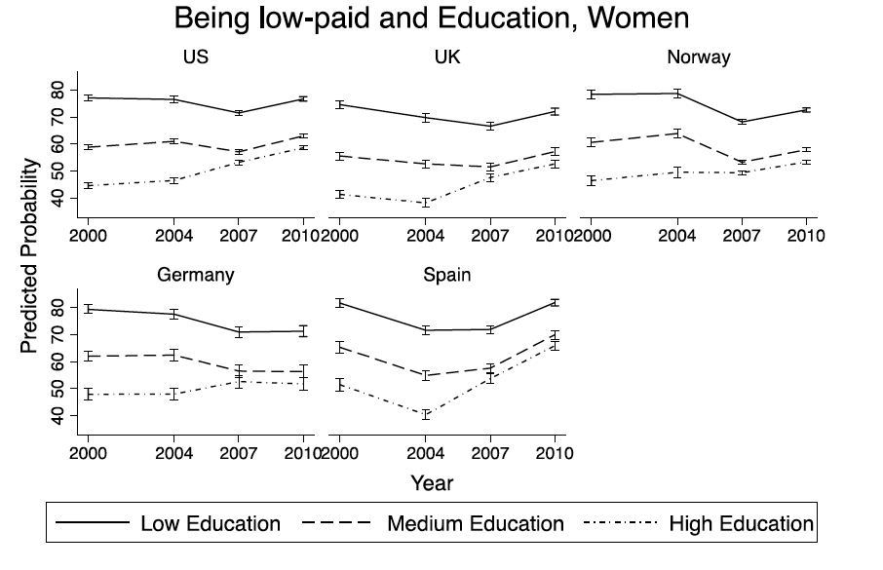

E

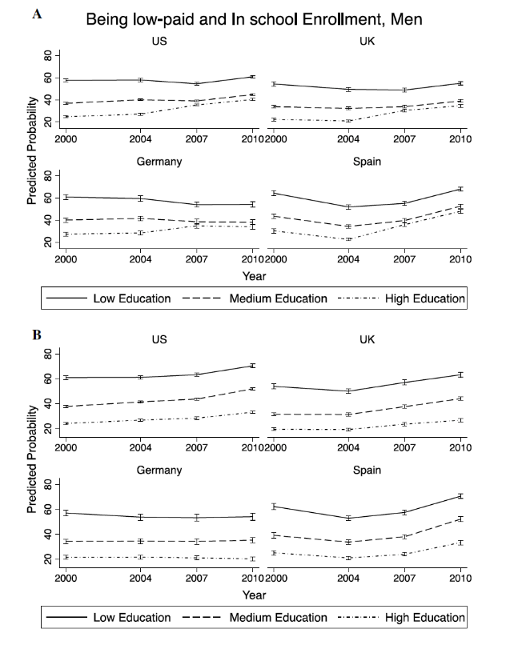

F

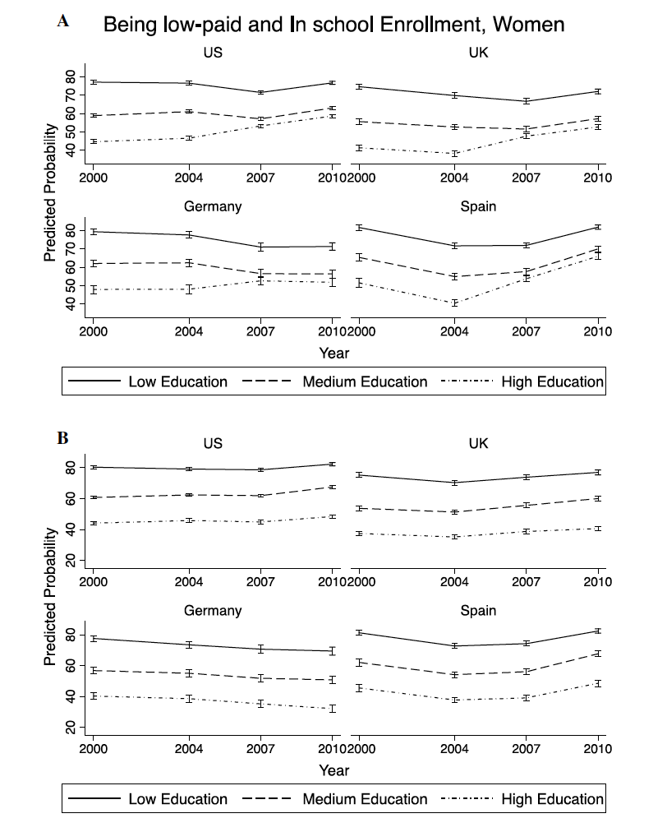

G
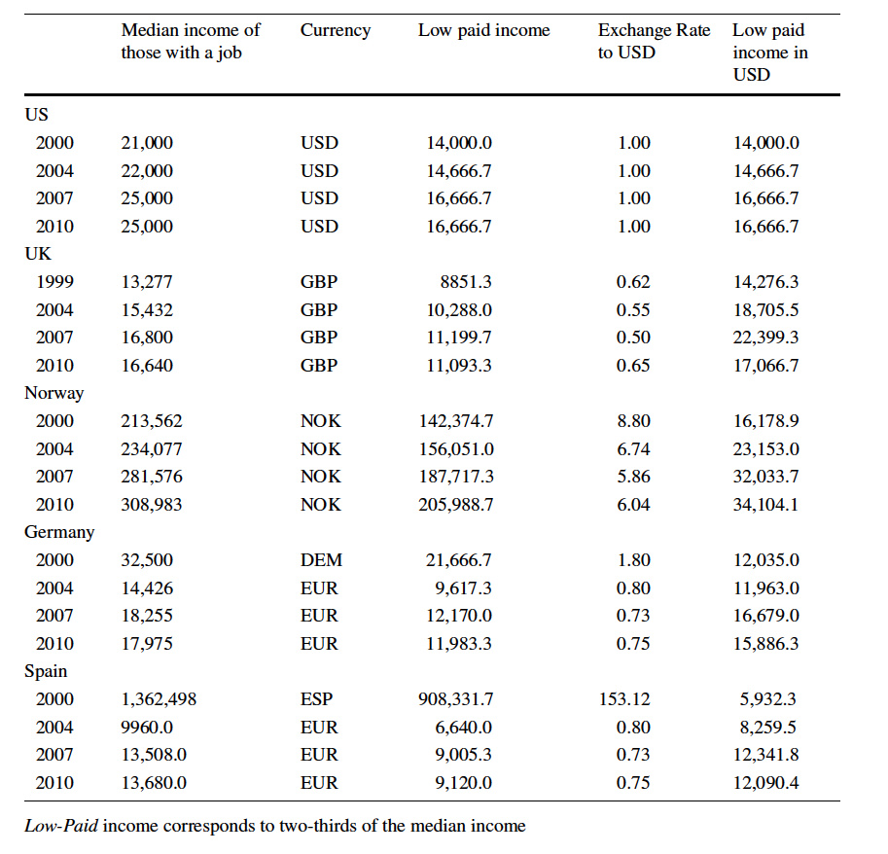

H

