Posters: Matching Content and Layout

Contribution

What interesting contribution(s) does your project make to knowledge? Try to write it in one sentence, or a few bullet points:

…………………………………………………………………………………………………………………..

Think about what you would like your audience to remember about your project:

- Is it a problem-solution study?
- Is it the applications of a new technology or process, or a new combination of these?
- Is it the scope of a current or future problem?
- Is it a contrast? (old vs. new / before and after / technology A vs B)
- Is it a cost-effectiveness study?

Choosing a layout

Choosing an overall layout appropriate to the main message you want to get across is the most important step.
Think of a quilt

It's big and rectangular, and right away you notice a pattern. Similarly, a poster should have a suggestive arrangement of communication areas.

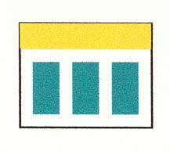  Left-to-right flow in vertical columns | 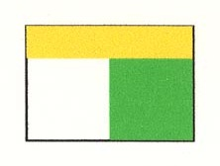  Two fields in contrast
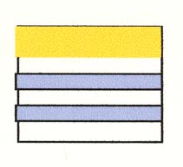  Left-to-right flow in horizontal rows | 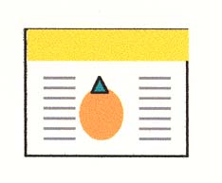  A centred image with explanations

This is the most challenging part of design: matching the physical pattern of the layout with the intellectual pattern of your main message.

TASK: Get some paper and roughly sketch out 3 or 4 different layout designs. Make sure you note what your section headings will be, and what your figures/visuals will be. Show them to your partner and get some feedback on the clarity, flow and attractiveness of the different designs.

