**Ways of describing data**

As well as presenting your data as frequency table, you must describe the most interesting points of these findings in words. Varying your vocabulary can improve your description. For example:

* Approximately 1,800 children between the ages of 5 and 12 were randomly selected ....
* Already 3% of the US working populations (1.55 million) are employed in 70,000 centres....
* The earth’s atmosphere appears to be gaining 3.3 billion metric tons of carbon annually....
* ....but five winters in the twentieth century were more than 2.4oC colder than average.

Percentages are commonly used for expressing rates of change or comparing groups. For example:

* Between 2000 and 2001 the number of overseas students increased by 27%
* 87% of women claimed to prefer chocolate to football, whilst only 27% of men did.

However, lots of statistics can become hard to read, and if the numbers are presented visually, it can be helpful to use words to vary your descriptions. For example:

* *Few* students attended her lecture (less than expected)
* *Several* bodies have been discovered under the temple floor (3-4)
* *Various* attempts were made to explain the symbols (3-6)
* *Dozens* *of*  politicians attended the opening ceremony (30-60)
* *Scores of* people were killed in the landslide (60+)

Alternatively, different numeric expressions can be used. For example:

|  |  |
| --- | --- |
| * One in three * A third / quarter * Twice as many * The majority / minority * A tenfold increase | * Double the number / Half the number * The most / the least * On average * A small / large proportion * A fairly steady number |

**Task 3:** Rewrite each of these sentences using some of the expressions or phrases above. If possible, simplify the way the data is described, to make it easier to understand.

1. Only four people responded to the questionnaire

**Few p**eople responded to the questionnaire (4) (4)

____________________________________________________________

1. She made five or six proposals to improve the team’s performance

**Various** proposals were made to improve the team’s performance._**____**________________________________________________________

1. Out of eighteen students in the group, twelve were women

**The majority o**f students in the group were women . Most students in the group were women.

_____________________________________________________________

1. Last year the number of students on the course was twenty-four, the year before it was twenty and this year it is twenty-two.

_On average, there are twenty-two students on the course. ___Approximately 22 students take this course. _____________________

1. Only 8% of the women surveyed believed that they had the same rights as men. A considerable 37% complained that they had far fewer rights.

_______________________________________________________________

_______________________________________________________________

1. Life expectancy for men in the UK rose from 49 to 74 during the twentieth century (**25)**

_On average life expectancy for men in the UK rose 25 years. ____________________________________________________________

1. In 1086 about 15% of England was forested, compared with only 4.8% in 1870

Approximately 15% of England was forested, compared with only 4.8% in 1870. ________________________________________________________

1. The numbers applying to this department have risen from 350 last year to 525 this year. (175)

**Numbers applying to this department have increased significantly from 350 last year to 525 this year. There has been a significant increase in applicants this year...**  _______________________________________________________________

1. Fifteen of the students studied law, eight finance and three engineering.

**The majority of students studied law, _(15) approximately 8 studied Finance and the minority studied Engineering.**

1. He found over fifty factual errors in the article.

_____ **Dozens of factual errors were found in the article. __**_______________________________________________________

1. More than 80% of British students complete their first degree course; in Italy the figure is 35%

**A large proportion of British students complete their first degree- (80%) a smaller proportion of Italian students finish their degree (35%) (___**____________________________________________________________

1. The number of visitors to the temples show a remarkable pattern. In 1998 just 40,000 made the journey, 83,000 in 1999 and 171 in 2000.

The number of visitors to the temples doubled in 1999 and significantly decreased in 2000. ____________________________________________________

[Adapted from Bailey (2003), *Academic Writing*, London: Routledge, 92-94]

**Write a paragraph describing this table. It shows mean values of Likert Scale questions where participants were asked to say how important each factor is in influencing their choice of bank (1 is not at all important and 5 very important).**

**On a scale of 1-5**

**The majority of participants say that bank security and a good reputation extremely important (4.13) This also applies to customer service...**

|  |  |
| --- | --- |
| **determinants** | **mean** |
| bank security | 4.133 |
| good reputation | 4.133 |
| customer service | 4.1 |
| proximity of ATMs | 4 |
| technological service | 3.867 |
| recommendation by friends or family | 3.7 |
| low service charge | 3.6 |
| high interest rate | 3.133 |
| recommendation by advertisement | 2.767 |

**Write a paragraph describing this graph. It shows mean values of Likert Scale questions where participants were asked to say how important each factor is as an advantage of shopping online (1 is not at all important and 5 very important). Note, ‘Full’ means a wide choice**

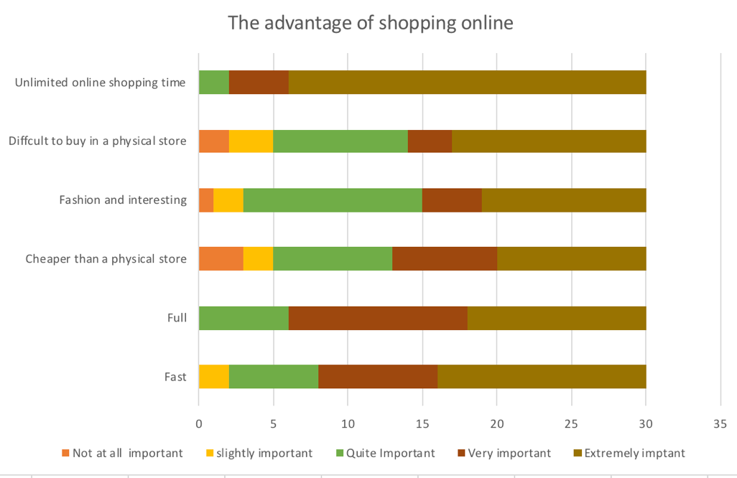

**Write a paragraph describing this pie chart. Participants (students) were asked to say how frequently they visited a street bank before banking online**

