PM600 Evaluating Draft Research Proposals

## Task:

*Look at the two example draft proposals below, using the marking criteria to help you.*

* Which proposal is stronger?
  + Why?
* Write three pieces of advice for each student on how to improve their proposal before submission.

## Marking criteria:

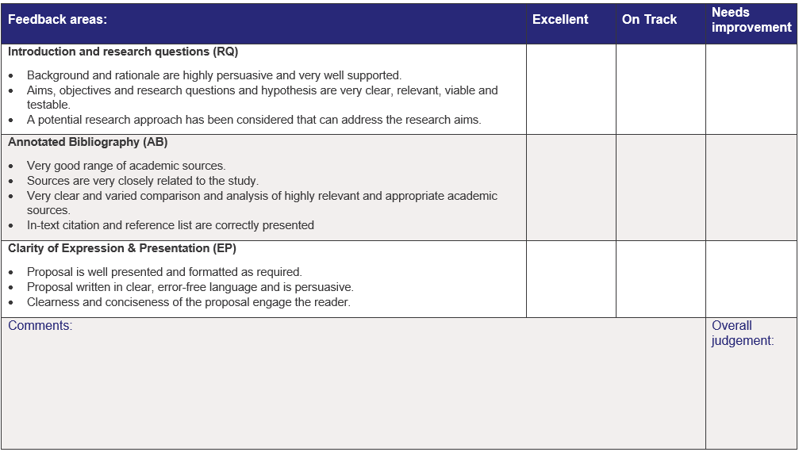

Example Draft Proposal 1: Primary Research.

|  |  |  |
| --- | --- | --- |
| **SECTION 1: Project Title (10-20 words)** |  |  |
| Awareness and knowledge of sexual and reproductive health issues among international students in Liverpool International College | | |
| **SECTION 2: Introduction (300 words)** This section must contain: | | |
| **Background:**  Sexual and reproductive health (SRH) issues are not openly discussed yet probably one of the most important issues that young people face in their lives. Awareness, knowledge and behaviour of SRH issues tend to vary from country to country with respect to education system, family discipline, social environment, religion, beliefs and so on. | | |
| **Rationale:**  Existing research on SRH is limited because it only targets certain groups of people in particular geographical area. There is a research gap in information from international students from countries with different cultural and religious background. Terms such as family planning, unintended pregnancy as well as STD and HIV might sound familiar to some students; however, in some cases, these terms might be completely new vocabulary to some of them too. Given the fact that most of students in LIC are at reproductive age and living alone far from their parents' surveillance, they are likely to engage in risky sexual behaviour. Lack of knowledge on SRH can cause serious damages to one's health in general; body, mind and reputation. Acquiring awareness and knowledge of SRH is the first step towards recognising and preventing higher-risk sexual behaviour. | | |
| **Research aim:**  This project aims to determine awareness of international students in LIC towards SRH, to assess the knowledge extent of international students in LIC on SRH, and to determine the main sources of information regarding to SRH. | | |
| **Draft research question(s):**  What is LIC students’ knowledge level on SRH? | | |
| **Research approach:**  This research intends to utilize quantitative approach in order to gain sufficient, clear and statistical data. Given the fact that research questions are measurable and demand more of data collection, quantitative research is more suitable than qualitative in this case of research topic area.  Method of questionnaire will be applied that assesses international students' awareness, knowledge level as well as popularity of information sources which also attempt to fill the gap in existing literature reviews. | | |
| **SECTION 3: Annotated Bibliography (about 700 words)** | | |
|  | | |
| 1 Delva, W., Wuillaume, F., Vansteelandt, S., Claeys, P., Verstraelen, H., &Temmerman, M. (2007). Sexual behaviour and contraceptive use among youth in the Balkans. European Journal Of Contraception & Reproductive Health Care, 12(4), 309-316.  Delva et al. (2007) stressed that the least proportion of youth in Balkan countries mentioned medical caregivers or school as source of information. Moreover, Delva et al. (2007) stated that youth in the Balkans seem to place themselves more frequently at risk for pregnancy than youngsters from some West-European countries. In terms of main sources of information on the issue of sexuality for young people, most of them were unreliable sources. | | |
| 2 Khajehei, M., Ziyadlou, S., &Ghanizadeh, A. (2013). Knowledge of and attitudes towards sexual and reproductive health in adults in Shiraz: a need for further education. Eastern Mediterranean Health Journal, 19(12), 982-989.  Khajehei (2013) found that awareness, general knowledge on SRH is low in many countries. Due to cultural issues and religious factors. They estimated that the overall level of knowledge on SRH among men and women in Iran was low and majority of them had incorrect knowledge or did not know about contraceptive use. In addition, SRH knowledge differed depending on gender in some countries. Khajehei (2013) depicts that the mean score of knowledge about STI was higher among men than women in Iran. | | |
| 3 McManus A, Dhar L. Study of knowledge, perception and attitude of adolescent girls towards STIs/HIV, safer sex and sex education: a cross sectional survey of urban adolescent school girls in South Delhi, India. BMC Women's Health, 2008  Indian women named internet, friends, books and magazines as their common sources of SRH information. (McManus and Dhar, 2008) | | |
| 4 Nair, M., Leena, M., Thankachi, Y., George, B., & Russell, P. (2013). ARSH 1: Reproductive and sexual health problems of adolescents and young adults: a cross sectional community survey on knowledge, attitude and practice. Indian Journal Of Pediatrics, 80.  According to Nair (2013), higher percentage in the older age group depends more on friends and magazines for SRH knowledge in India compared to study conducted by Delva et al. (2007) older Balkans considered that media was least source of choice on SRH. While younger age group in India depends more on mother and teachers (Nair, 2013), their counterparts in Balkans mentioned media as their source of SRH information. (Delva et al. 2007) | | |
| 5 Rafia, B., & Al-Sabhan, F. A. (2015). Study of knowledge and practice of university females regarding reproductive health and hygiene in hail, Saudi Arabia. International Journal Of Women's Health And Reproduction Sciences, 3(1), 31-39.  Similar conclusions as Khajehei (2013) were drawn from the 'study of knowledge and practice of University females regarding reproductive health and hygiene in Saudi Arabia'; indicating 38% of the girls were unaware of STD/AIDS. (Rafia and AI Sabhan, 2015) Although this research is relatively recent, it has to be mentioned that Rafia &AI Sabhan targeted only females as their research focus group. As far as the knowledge of the use of contraceptives was concerned, less than half of the young women (46.7%) had known what actually contraceptives are in Saudi Arabia. | | |
| **SECTION 4: Working Bibliography (not included in the word count)** | | |
| This section should list all the relevant sources you have gathered for the purpose of your project, including the sources included in the Annotated Bibliography and anything cited in the introduction. Your references should follow APA format, listed from A-Z. A minimum of five sources must be given. | | |
| Delva, W., Wuillaume, F., Vansteelandt, S., Claeys, P., Verstraelen, H., &Temmerman, M. (2007). Sexual behaviour and contraceptive use among youth in the Balkans. European Journal Of Contraception & Reproductive Health Care, 12(4), 309-316.  Khajehei, M., Ziyadlou, S., &Ghanizadeh, A. (2013). Knowledge of and attitudes towards sexual and reproductive health in adults in Shiraz: a need for further education. Eastern Mediterranean Health Journal, 19(12), 982-989.  McManus A, Dhar L. Study of knowledge, perception and attitude of adolescent girls towards STIs/HIV, safer sex and sex education: a cross sectional survey of urban adolescent school girls in South Delhi, India. BMC Women's Health, 2008  Nair, M., Leena, M., Thankachi, Y., George, B., & Russell, P. (2013). ARSH 1: Reproductive and sexual health problems of adolescents and young adults: a cross sectional community survey on knowledge, attitude and practice. Indian Journal Of Pediatrics, 80.  Rafia, B., & Al-Sabhan, F. A. (2015). Study of knowledge and practice of university females regarding reproductive health and hygiene in hail, Saudi Arabia. International Journal Of Women's Health And Reproduction Sciences, 3(1), 31-39.  Shi, Y., Ji, Y., Sun, J., Wang, Y., Sun, X., Li, C., & ... Chang, C. (2012). Lack of health risk awareness in low-income Chinese youth migrants: assessment and associated factors. Environmental Health And Preventive Medicine, 17(5), 385-393.  Stern, E. )., Cooper, D. )., & Gibbs, A. ). (2015). Gender differences in South African men and women's access to and evaluation of informal sources of sexual and reproductive health (SRH) information. Sex Education, 15(1), 48-63.  Tarar, M. A., Akhtar, S., Zafar, M. I., & Muhammad, S. (2015). REPRODUCTIVE HEALTH; PERCEPTIONS, ATTITUDES AND PRACTICES AMONG YOUNG FEMALES IN FAISALABAD DISTRICT, PAKISTAN. Professional Medical Journal, 22(1), 1. | | |

Example Draft Proposal 2: Secondary Research

|  |  |  |
| --- | --- | --- |
| **SECTION 1: Project Title (10-20 words)** |  |  |
| Natural method for enhancement immune system for treatment cancer cells | | |
| **SECTION 2: Introduction (300 words)** This section must contain: | | |
| **Background:**  Cancers are kind of tumors. There are group of cells which is extraordinary to division themselves uncontrollably. These cells can spread out via lymph and blood vessel. There are many carcinogens lead to cancers. The researcher found that smoking cause mortality approximately 22 %( Global, 2017). The other determinant are hygiene, infection and radiation exposure. Therefore, more than 90% result from environmental factor (The American Cancer Society, 2017).The bodies have their methods to remedy itself. One of this factor is genetic in individual. The researcher found 5-10% of cancer can be investigated to genetic implicate (The American Cancer Society, 2017).  Immune system is the wall of individual bodies. Sometimes people mention this system be a soldier of the human. The immune system can identify what exist in their own body, what are unknowns. Therefore, they will kill the other which is they not recognised. The NK cells are natural killer cells which kill tumours or cancer cells specifically by release chemical to stimulate apoptosis of abnormal cells. | | |
| **Rationale:**  Nowadays, there are many methods to treat cancer for instance Chemotherapy, surgery, and immunotherapy. Surgery is gold standard to remedy cancer. However, when cancer occur in the position which is unable to cut it out, or it is risk to spread out, doctor need to use the other alternative methods to rescue patient.  There are many patients have been suffered from treatment of cancer. The way for treatment cancer follows by significantly of side effect. Some of them have got hair lose, platelet anaemia or immunodeficiency. This because patient got infectious from the other bacteria. Therefore, the alternative way to treatment cancer is very indispensable. | | |
| **Research aim:**  Find out the natural methods to treatment cancer by enhance immune system | | |
| **Draft research question(s):**  1. What is method we use to rescuers cancer cell?  2. How do Immune relatives to cancer cell?  3. Which natural substance can improve ability of immune system?  4. Effect of herb for enhancement immune system  5. Effect of herb treatment for cancer cell  6. Is natural method can fully compensate the chemical methods? | | |
| **Research approach:**  Gather information via review secondary research. Moreover, I need to find primary research to prove this theory. | | |
| **SECTION 3: Annotated Bibliography (about 700 words)** | | |
|  | | |
|  | | |
|  | | |
|  | | |
|  | | |
|  | | |
| **SECTION 4: Working Bibliography (not included in the word count)** | | |
| The American Cancer Society medical and editorial content team, (2017) *Family Cancer Syndromes .* March 25, 2017 < <https://www.cancer.org/cancer/cancer-causes/genetics/family-cancer-syndromes.html>>  Elham Safarzadeh, Siamak Sandoghchian Shotorbani & Behzad Baradaran (2014), ‘*Herbal Medicine as Inducers of Apoptosis in Cancer Treatment’, Advanced Pharmaceutical Bulletin*, Vol 4, Iss suppl 1, Pp 421-427 (2014), no. suppl 1, p. 421, viewed 2 February 2019.  Global, *regional, and national comparative risk assessment of 84 behavioural, environmental and occupational, and metabolic risks or clusters of risks for 195 countries and territories ,1990-2017: a systematic analysis for the Global Burden of Disease Study 2017’* (2018) Lancet (London, England), 392(10159), pp. 1923–1994. doi: 10.1016/S0140-6736(18)32225-6.  Young, A., Quandt, Z. & Bluestone, J. A., n.d., ‘*The Balancing Act between Cancer Immunity and Autoimmunity in Response to Immunotherapy*’, CANCER IMMUNOLOGY RESEARCH, vol. 6, no. 12, pp. 1445–1452, viewed 28 January 2019,  Sompayrac, L. M. (2015), *How the Immune System Works*, John Wiley & Sons, Incorporated, New York. Available from: ProQuest Ebook Central. [2 February 2019].  Safarzadeh, E. Shotorbani, S.S., & Baradaran, B., (2014), *‘Herbal Medicine as Inducers of Apoptosis in Cancer Treatment*’, Advanced Pharmaceutical Bulletin, vol. 4, pp. 421–427, viewed 28 January 2019, | | |