Additional Information

Balanced Networking Scorecard

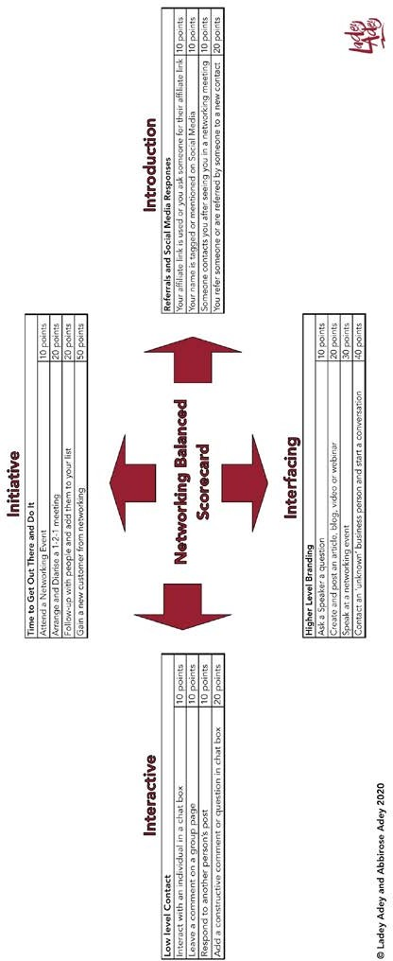

Your Path, Your Way to Successful Networking

Your Networking Scores
P
rint off this page and use this table to add up your score on a weekly basis. Give yourself points for EVERY time you do an activity.
The only competition here is with yourself. It provides vital data to your networking activity; to help decide whether you are receiving a good return on your investment.

Your Networking Scores
Week Commencing:
Activity | Points | Your Score
Initiative (Get Out There & Do It)
Attending a Networking Event | 10
Arrange and Diarise a 1-2-1 Meeting | 20
Follow up and Add Contact to List | 20
Gain a New Customer from Networking | 50
Total
Introduction (Referrals and Social Media)
Your affiliate link is used or you ask someone for their affiliate link | 10
Your name is tagged or mentioned on Social Media | 10
Someone contacts you after seeing you in a networking meeting | 10
You refer someone or are referred by someone to a new contact | 20
Total
Interfacing (Higher Level Branding)
Ask a Speaker a question | 10
Create and post an article, blog, video or webinar | 20
Speak at a networking event | 30
Contact an ‘unknown’ business person and start a conversation | 40
Total
Interaction (Low Level Contact)
Interact with an individual in a chat box | 10
Leave a comment on a group page | 10
Respond to another person’s post | 10
Add a constructive comment or question in chat | 20
Total

Additional Information

For each month do a summary sheet using your weekly score results.

Your Networking SUMMARY Scores
Month:
Activity | FINAL  Scores
Initiative (Get Out There & Do It)
Attending a Networking Event
Arrange and Diarise a 1-2-1 Meeting
Follow up and Add Contact to List
Gain a New Customer from Networking
Total
Introduction (Referrals and Social Media)
Your affiliate link is used or you ask someone for their affiliate link
Your name is tagged or mentioned on Social Media
Someone contacts you after seeing you in a networking meeting
You refer someone or are referred by someone to a new contact
Total
Interfacing (Higher Level Branding)
Ask a Speaker a question
Create and post an article, blog, video or webinar
Speak at a networking event
Contact an ‘unknown’ business person and start a conversation
Total
Interaction (Low Level Contact)
Interact with an individual in a chat box
Leave a comment on a group page
Respond to another person’s post
Add a constructive comment or question in chat
Total

A copy of an interactive tool to help you produce your own scorecard is available in the ‘networking skills’ section of Pathways Extra in the Kaplan International Pathways Virtual Learning Environment.

